**CSA09 Programming in Java**

**Day 1- Assignment**

**1.Given a non-negative integer x, return the square root of x rounded down to the nearest integer. The returned integer should be non-negative as well.**

**You must not use any built-in exponent function or operator.**

**For example, do not use pow(x, 0.5) in c++ or x ** 0.5 in python.**

**Example 1:**

**Input: x = 4**

**Output: 2**

**Explanation: The square root of 4 is 2, so we return 2.**

**Example 2:**

**Input: x = 8**

**Output: 2**

**Explanation: The square root of 8 is 2.82842..., and since we round it down to the nearest integer, 2 is returned.**

class Solution {

    int mySqrt(int x) {

    }

}

Solution:

import java.io.*;

import java.util.*;

class s

{

public static void main(String[] args)

{

try

{

int i,n,m;

Scanner sc=new Scanner(System.in);

System.out.println("ENTER THE NUMBER");

n=sc.nextInt();

for(i=1;i<=n;i++)

{

m=i*i;

if(m==n)

{

System.out.println("The square root: "+i);

}

}

}

catch(Exception e)

{

System.out.println("Invalid");

}

}

}

**Output:**

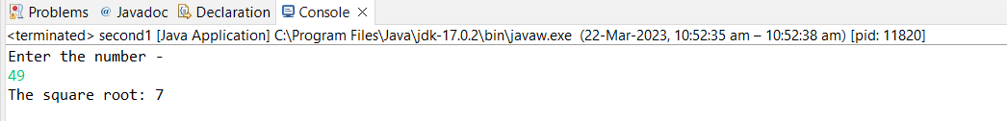

**2.Given an integer x, return true if x is a**

**palindrome**

**, and false otherwise.**

**Example 1:**

**Input: x = 121**

**Output: true**

**Explanation: 121 reads as 121 from left to right and from right to left.**

**Example 2:**

**Input: x = -121**

**Output: false**

**Explanation: From left to right, it reads -121. From right to left, it becomes 121-. Therefore it is not a palindrome.**

**Example 3:**

**Input: x = 10**

**Output: false**

**Explanation: Reads 01 from right to left. Therefore it is not a palindrome.**

**class Solution {**

**bool isPalindrome(int x) {**

**}**

**}**

**Solution:**

import java.io.*;

import java.util.*;

class palindrome

{

public static void main(String args[])

{

try

{

int a,m,n,rev=0;

Scanner sc=new Scanner(System.in);

System.out.println("Enther the number to be checked: ");

m=sc.nextInt();

a=m;

while(m>0)

{

n=m%10;

rev=rev*10+n;

m=m/10;

}System.out.println("The reverse num is: "+rev);

if(rev==a)

{System.out.println("is a palindrome");

}else{

System.out.println(" is not a palindrome");

}

}

catch(Exception e)

{

System.out.println("Invalid");

}

}

}

**Output:**

